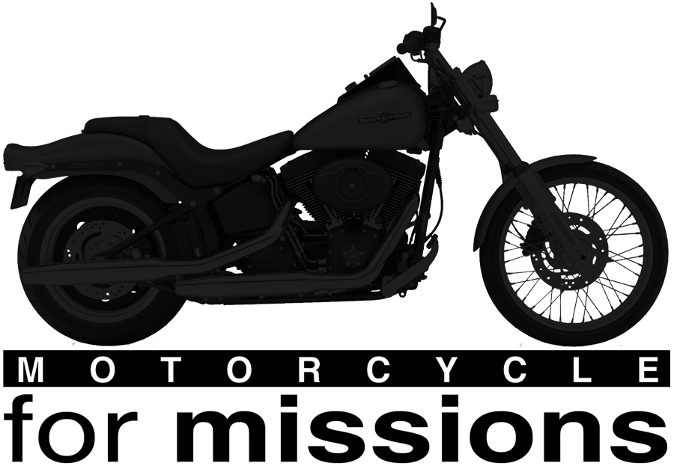

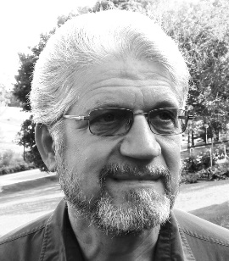
Greetings Motorcycle Riders and Sponsors,

The weather is warming up, spring is in the air, the cycles are running and it is time, once again, to be thinking about the fifth-annual Motorcycle for Missions ride in support of Virginia Mennonite Missions (vmmissions.org). Plans are being made, routes identified and sponsors contacted to make this ride another very special event!

The ride this year is set for Friday and Saturday, June 9-10, 2017. Following the feedback that we received from the survey after last year’s ride, we are planning two separate rides for Friday, June 9. The longer ride will leave Harrisonburg and head north on route 42, follow very scenic Wolf Gap Road and Trout Run Road, connect to Route 55, very short stretches of I-81 and I-66 to Front Royal, then travel south through Culpeper, Orange, Charlottesville, Farmville, and on to Roanoke where we will stay in the same Baymont Inn and Suites that we have used the last two years. The long ride will travel approximately 333 miles with a little over seven hours of riding. The shorter ride will leave Harrisonburg and travel east on route 33, south on route 340 to Waynesboro, route 250 to Afton, travel south to connect with route 29, on through Lynchburg and then west on route 24 to Roanoke ending at the same Baymont Inn and Suites. The shorter ride will cover about 169 miles and a little over three and one-half hours riding time. We will plan to eat dinner on Friday evening as a total group at Golden Corral as we have the last two years.
Our Saturday route will be as a total group from Roanoke a short distance on I-81 then getting on the Blue Ridge Parkway and traveling it all the way to Afton. From Afton we will take route 250 to route 340 and return to Harrisonburg, planning to arrive early afternoon and eating together at the Taste of Thai restaurant for a wrap up of the ride. Total mileage for Saturday’s ride is 166 miles.
Our goal this year is to have 20-24 riders and to raise at least $10,000 for VMM. We are asking each rider to raise at least $100, as before, to participate in the MFM ride. If each rider sets a goal of at least $500 in donations and pledges, we should easily reach our goal this year. All funds raised by the ride will go to VMMissions to support missions. Most expenses for the trip will be covered by the riders with some help through donations by sponsors.
Please register by May 25 by filling out the attached registration and release forms and return them to me, Robert G. Wenger, 2260 Old Trail Way, Rockingham, VA 22802. We need to have a final count to Baymont Inn by May 30.
Feel free to contact me for information or with questions at rolowenger@gmail.com or call me at 540-383-5094.
We hope that you can join us for this relaxing and invigorating ride which always includes good fun, good food and wonderful fellowship. Start now by encouraging your friends to join the ride, contacting persons to sponsor you and don’t forget to give your congregations the opportunity to join in supporting VMMissions through this endeavor.

With great anticipation,
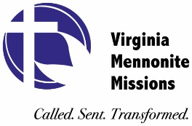
Robert G. Wenger, Coordinator
Motorcycle for Missions
Motorcycle for Missions
2017 Registration Form

Motorcyclists and Passenger Information: (Motorcyclists must be at least 21 years old and if the passenger is a minor then they must sign a consent form.)

Name______________________________ Passenger___________________________

Address_____________________________________

City_______________________________ State_____________ Zip code__________

Cell_________________________ Home______________________

Email __________________________________________

I plan to ride the _____ Long Route (2 day-499mi.) _____ Short Route (2 day-335mi.)

Emergency Contact:

Name____________________________Cell_________________Home_____________

General information:

Total cost to rider is estimated at $100-$175. This includes overnight accommodations (in Roanoke and in Harrisonburg, if needed). This is strictly an estimate and may be more or less depending on business sponsor support.

- A support/follow up vehicle will be pulling a trailer with tools, snacks, drinks, gas, and other items for emergencies.
- Each rider will receive a t-shirt.
- There will be a safety session for all riders concerning safety, specific plans, and routes prior to each start time.
- All riders and passengers will sign a liability waiver relieving VMM & event organizers of responsibility in case of accident.
- Riders are required to raise a minimum of $100 to participate in the ride.
- Corporate sponsors will partially cover the expenses for the trailer vehicle, t-shirts and snacks. Sponsors who gave a certain amount have their logo printed on the shirts. Any proceeds that exceed expenses will go to the VMM Mission Fund.

Ride Itinerary 2017

Friday, June 9

7:30 am Pre-ride information session: all participants must attend
8:00 am Leave Harrisonburg or Durham
5:00 pm Arrive in Roanoke
6:00 pm Dinner

Overnight lodging in Roanoke

Saturday, June 10

8:00 am Riders’ information session
8:30 am Leave Roanoke (including Ride Blue Ridge Parkway)
2:00 pm Lunch in Harrisonburg

2017 Sponsor/Pledge Form

Join VMM in our mission to introduce people to Jesus!
All proceeds will go to Virginia Mennonite Missions.

************************************************************************

Motorcyclist’s name: __________________________________________

Pledge or donor’s name: ______________________________________

Address: ____________________________________________

City: ____________________________ State: ______________ Zip: ___________

Phone: ___________________________ e-mail:________________________________

Church (optional):__________________________________________________________

Pledge amount: $_____________ Amount paid: $_________________
or
Pledge amount per mile $___________ Total miles: _________ Total pledged $_____________

Thank you for supporting Virginia Mennonite Missions through Motorcycle for Missions!

Make checks payable to:
Virginia Mennonite Missions
601 Parkwood Drive
Harrisonburg, VA 22802
(designate motorcyclist's name)

Please fulfill pledge by June 30, 2017

2017 MOTORCYCLIST RELEASE FORM

RIDER’S NAME: _____________________________________________________

PASSENGER NAME: _____________________________________________________

I acknowledge that I am 18 years of age or older and that participation in Motorcycle for Missions is a potentially hazardous activity. I will not participate unless I am medically able to do so, am properly trained and have resources to cover medical costs for injuries that may occur. I assume all responsibility for the risks associated with participation in this event, including accidental injury or death resulting from falls, contact with other riders, and contact with traffic along the route. I will pay my own medical expenses in the event of an accident, illness or other incapacity and will not hold Virginia Mennonite Missions or the event organizers responsible for those expenses or other losses I, or my family, may incur if I am injured. I waive any and all additional notice of the existence of dangerous conditions associated with Motorcycle for Missions and assume responsibility to exercise my own judgment in evaluating those conditions.

With knowledge of these facts, I, or my heirs and anyone acting on my behalf, discharge and release Virginia Mennonite Missions and the ride organizers from any and all claims and actions at law for damages or monetary awards arising out of my participation in Motorcycle for Missions including injury to my person or property caused by any act or failure to act by the above entities and persons.

I will wear a helmet and obey the rules of the road. By signing my name below, I intend to be legally bound by all the terms and conditions of this assumption of risk and waiver of claims.

Rider Signature: _________________________________ Date:________________

Passenger Signature: ____________________________ Date: ________________

