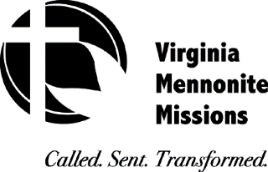
2018 Auction Form
Friday, May 11th, 2018
Eastern Mennonite High School Dining Hall
Fundraiser Meal & Silent Auction @ 5 p.m.
Live Auction @ 6:00 p.m.

Donation Information Sheet

Dear Donor,

Thank you for contributing an item to be auctioned at VMMissions’ 2018 Auction in support of our workers in the U.S. and across the world! We are looking forward to this annual event and appreciate everyone who is helping make it a success.

Please complete this form for each item you intend to donate:

Donor’s Name
Donor’s Address
Item Description
(Limit 10 words)
*Donor’s Estimated Fair Market Value for Item (Required by law) |  | $ .
Name of VMMissions’ Worker(s) you are supporting with this contribution

To include your item on the Auction List, please send an email to jon.trotter@vmmissions.org between now and May 4. Attach to the email a copy of this completed form and a picture of the item. A jpeg file is preferred for the pic option.
Delivery information – Items can be dropped off at the EMHS main campus dining hall the week of May 7-11.
To schedule delivery please contact Mindy Schwartz, 540-421-0167; mindy.schwartz@vmmissions.org or Steve Leaman, 540-578-2437 at VMMissions’ office.
Please print this form and attach it to the donated item for proper tracking.

After the item is sold at auction, VMMissions will issue you a gift acknowledgement that confirms that VMMissions received the donated item described above. Consistent with IRS regulations, VMMissions will not assign a value to the donated item. If you intend to claim the value of the item as a charitable deduction, you should keep the VMMissions’ gift acknowledgement and any documentation that substantiates the value you are claiming. We will mail you the gift acknowledgement receipt after the auction.

*Item cannot be accepted until this field has been completed, specifically, by the donor.

